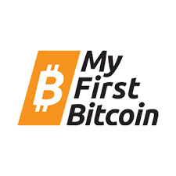 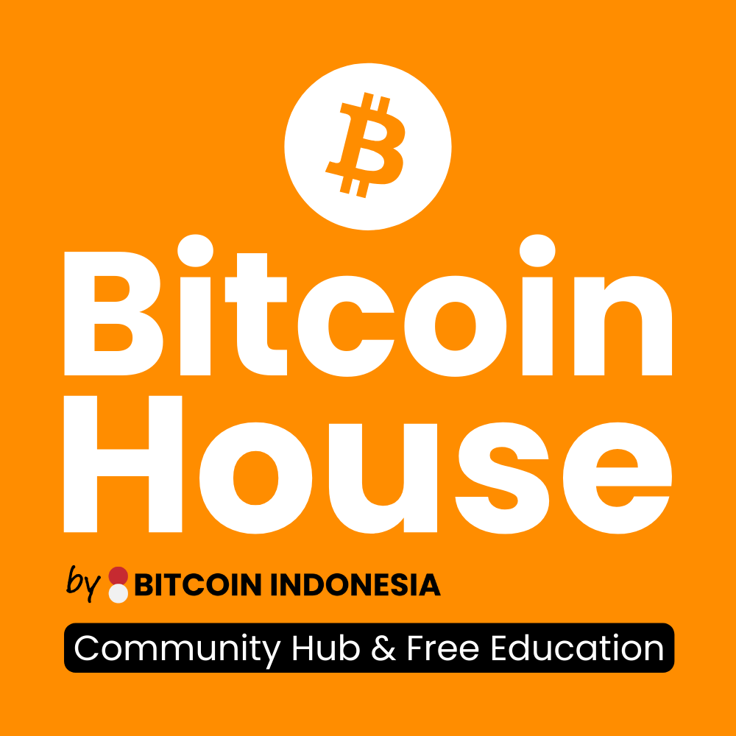

**My First Bitcoin - Bali: Final Exam**

Dear students,

You have done a great job so far and you should be very proud of yourselves. By deciding to learn about Bitcoin, you have taken your lives in a whole new direction. Now it's time to test your knowledge and review what you've learned over the past 10 weeks.

This test consists of 21 Multiple Choice questions and 3 open questions, where you can write a short text or some bullet points. You have 30 min to answer all questions.

Semangat!

Guru-guru favorit kalian 🧡💜

### **Part 1: Multiple Choice (only 1 answer is correct)**

1. **What is Bitcoin?**
2. Bitcoin is a type of stock or bond
3. Bitcoin is a neutral and decentralized protocol that issues a new form of money
4. Bitcoin is a trading token like the other cryptocurrencies
5. Bitcoin is a centralized digital currency controlled by a single entity
6. **What is the main goal of learning how to use Bitcoin?**
7. To be in control of your own money
8. To become a professional trader
9. To entrust your bitcoins to a bank
10. To create a new Bitcoin protocol
11. **What technologies does the Bitcoin protocol use?**
12. Cryptography, network communication, and the blockchain
13. Quantum computing, network communication, and the blockchain
14. Cryptography, artificial intelligence, and the blockchain
15. Artificial intelligence, machine learning, and the blockchain
16. **What does it mean for Bitcoin to be a neutral currency?**
17. It is controlled by a single entity or institution
18. It is only used for legal contracts
19. It is not controlled by any entity or institution
20. It is regulated by the government
21. **Satoshi Nakamoto created the Peer-To-Peer Cash System so that we …**
22. Give back power to the people and have money without the need for intermediaries
23. Buy bitcoin on a centralized exchange and upload our ID cards
24. Can allow governments to track our transactions in the mempool
25. Have a solution to avoid paying taxes
26. **What is a Bitcoin transaction?**
27. A transfer of ownership of Bitcoins, using a physical address
28. A physical exchange of Bitcoins
29. A transfer of ownership of Bitcoins, using a Bitcoin address
30. A transfer of ownership of Bitcoins, using an email address
31. **What is the main aim of Bitcoin?**
32. To make everyone rich through trading opportunities
33. To simplify online shopping globally
34. To separate the state from money through a decentralized network
35. To have darknet money for criminal activities
36. **From which movement did Bitcoin originate?**
37. From the Cypherpunks
38. From a group of Human Rights Activists
39. From anti-government protesters
40. From the Libertarian
41. **What are the 3 functions of money?**
42. Durability, divisibility, and scarcity
43. Portability, printability, and acceptability
44. Freedom, privacy, and censorability
45. Store of value, medium of exchange, and unit of account
46. **What is a low-time preference?**
47. The tendency to prioritize immediate rewards over future gains
48. Focusing on long-term benefits and delaying gratification
49. Making impulsive purchases for short-term excitement
50. Never spending your bitcoin
51. **What is the Lightning Network?**
52. An on-chain solution for everyday expenses
53. A solution to make Bitcoin more decentralized
54. The third layer for Bitcoin
55. A fast and easy payment system to scale Bitcoin
56. **What could be a downside of central bank digital currencies (CBDCs)?**
57. It could lead to a decrease in the value of Bitcoin
58. It could restrict individuals' financial freedom and offer governments full control of their people
59. It could lead to technical issues when making online payments
60. It could accelerate global warming
61. **How are Bitcoin miners incentivized?**
62. By getting discounts when buying bitcoin through an exchange
63. By donations from the community
64. By the block reward and the transaction fees of the mined block
65. By the block reward only
66. **What is the main disadvantage of fiat currencies?**
67. They are not backed by silver
68. Their value is manipulated by government policies
69. They are easy to be counterfeited
70. They are not very beautiful
71. **Bitcoin enforces Human Rights, like the Right to Equality, Freedom from Discrimination, Right to Privacy, Freedom of Movement, Right to Own Property & Presumption of Innocence.**
72. True
73. Wrong
74. **Bitcoin is …**
75. Permissionless, open-source, and uncensorable
76. Permissionless, closed-sourced, and censorable
77. Anonymous and requires permission from the community nodes
78. Only for the rich
79. **What is the environmental criticism of the current financial system?**
80. It does not invest in renewable energy
81. It promotes the use of fossil fuels
82. It encourages overconsumption and debt
83. It does not regulate the production of goods
84. **What does a “self-custodial” wallet refer to?**
85. It is a Bitcoin wallet of which you are sharing the ownership of the private keys with a company
86. It is a Bitcoin wallet of which you do not have access to the private keys
87. It is a Bitcoin wallet of which you are the sole owner of the private keys
88. It is a Bitcoin wallet of which you trust the wallet provider to secure your bitcoin
89. **Why do we use the Proof-of-Work in Bitcoin?**
90. To secure Bitcoin in a centralized way
91. To waste a lot of energy
92. To find a solution for otherwise unused energy
93. To secure Bitcoin in a decentralized way
94. **How to keep your bitcoin secure?**
95. By leaving it on a centralized, regulated exchange that I can trust
96. By storing it on my self-custody hardware wallet and having secure backups
97. By storing it on my phone without 2-Factor-Authentication
98. By storing it in my custody Lightning wallet
99. **What is a seed?**
100. My public address that I can share with others
101. A random combination of 12-14 words that gives me full ownership of my bitcoin
102. My private key
103. My 25th word to increase the security of my bitcoin

### **Part 2: Open Questions**

1. **Why is inflation a problem for our society? Name at least 3 consequences.**
2. **What are 3 key features of Bitcoin that distinguishes it from fiat currencies?**
3. **How could Bitcoin help Indonesia and yourself?**

**MFB Bali Cohort Answers:**

1. B
2. A
3. A
4. C
5. A
6. C
7. C
8. A
9. D
10. B
11. D
12. B
13. C
14. B
15. A
16. A
17. C
18. C
19. D
20. B
21. B